**Top 50 Tough Scenario Based questions on AWS related topics (Difficult Interview Preparation)**

If you prepare the questions below, you can crack any high-profile AWS interview easily — please answer in comment section

**Cost-Saving & Performance Optimization**

**Scenario 1: You need to optimize a highly transactional system hosted on AWS to reduce costs while improving performance. Describe a cost-effective strategy to move from Provisioned IOPS SSD (io1) to General Purpose SSD (gp3) volumes. How would you ensure minimal performance degradation during this transition?**

**Ans**:

**SSD (io1)** stands for:

* **SSD** = **Solid State Drive**  
  A type of storage device that uses flash memory for fast read/write operations (much faster than traditional HDDs).
* **io1** = **Provisioned IOPS SSD**  
  This is an Amazon EBS (Elastic Block Store) volume type where you can **provision a specific number of IOPS (Input/Output Operations Per Second)** for predictable, high-performance workloads.

Here’s a structured, cost-effective strategy for moving from **Provisioned IOPS SSD (io1)** to **General Purpose SSD (gp3)** on AWS while minimizing performance degradation:

**✅ 1. Understand the Differences**

* **io1**: High-performance, provisioned IOPS for mission-critical workloads.
* **gp3**: Lower cost, baseline performance of 3,000 IOPS and 125 MB/s throughput, with ability to provision up to 16,000 IOPS and 1,000 MB/s independently of storage size.

**Cost Advantage**: gp3 is up to **20% cheaper** than gp2 and significantly cheaper than io1 for similar performance.

**✅ 2. Pre-Migration Analysis**

* **Workload Profiling**:
  + Measure current IOPS, throughput, and latency on io1 volumes using **CloudWatch metrics**.
  + Identify peak usage patterns and ensure gp3 can meet or exceed these requirements.
* **Performance Baseline**:
  + Document current performance benchmarks for comparison after migration.

**✅ 3. Migration Strategy**

* **Option A: Modify Volume in Place**
  + Use **Elastic Volumes** feature to change the volume type from io1 → gp3 without detaching or stopping the instance.
  + This is **online**, minimal downtime, and cost-effective.
  + Command:

Shell

aws ec2 modify-volume --volume-id <volume-id> --volume-type gp3 --iops <desired-iops> --throughput <desired-throughput>

Show more lines

* **Option B: Snapshot & Restore**
  + Create a snapshot of io1 volume and restore it as gp3.
  + Suitable for non-critical workloads or when major resizing is needed.

**✅ 4. Performance Tuning**

* **Provision gp3 IOPS & Throughput**:
  + Match or slightly exceed current io1 IOPS and throughput to avoid degradation.
  + Example: If io1 had 10,000 IOPS and 500 MB/s, configure gp3 with similar values.
* **Monitor & Adjust**:
  + Use **CloudWatch** to monitor latency and IOPS post-migration.
  + Adjust gp3 settings dynamically if performance dips.

**✅ 5. Risk Mitigation**

* **Test in Staging**:
  + Migrate a non-critical volume first and run performance tests.
* **Enable EBS-Optimized Instances**:
  + Ensure EC2 instances are EBS-optimized for maximum throughput.
* **Use Multi-Attach or RAID** (if needed):
  + For extremely high IOPS workloads, consider RAID 0 across multiple gp3 volumes.

**✅ 6. Cost Optimization**

* **Right-Size Volumes**:
  + gp3 decouples storage size from performance, so avoid over-provisioning.
* **Leverage Savings Plans or Reserved Instances**:
  + Combine with EC2 cost optimization for maximum savings.

**✅ Expected Outcome**

* **Cost Reduction**: Significant savings compared to io1.
* **Performance Stability**: Minimal degradation if gp3 is properly tuned.
* **Flexibility**: Ability to scale IOPS and throughput independently.

**Provisioned IOPS SSD (io1)** is an Amazon Elastic Block Store (EBS) volume type designed for **high-performance, mission-critical workloads** that require consistently low latency and high I/O operations per second (IOPS).

Here’s what it means:

**✅ What is io1?**

* **Provisioned IOPS SSD (io1)** is an EBS volume type where you can **explicitly provision the number of IOPS** you need, independent of the storage size.
* It’s optimized for:
  + **Databases** (e.g., Oracle, SQL Server, MySQL)
  + **Transactional systems** with heavy read/write operations
  + **Latency-sensitive applications**

**✅ Key Characteristics**

* **Performance**:
  + You can provision up to **64,000 IOPS** per volume (when attached to Nitro-based EC2 instances).
  + Throughput up to **1,000 MB/s**.
* **Consistency**:
  + Designed for workloads that need predictable performance.
* **Durability**:
  + 99.999% availability and high reliability.

**✅ Cost**

* io1 is **expensive** because you pay for:
  + Storage capacity (GB)
  + Provisioned IOPS (each IOPS costs extra)

**✅ Why move to gp3?**

* gp3 offers **baseline 3,000 IOPS and 125 MB/s throughput** at a much lower cost.
* You can **scale IOPS and throughput independently** (up to 16,000 IOPS and 1,000 MB/s).
* Ideal for most workloads that don’t need ultra-high, guaranteed IOPS.
* Here’s a **quick comparison table** for **io1 vs gp3 vs gp2**:

create a quick comparison table (io1 vs gp3 vs gp2) with cost, performance, and use cases?

| **Feature** | **io1 (Provisioned IOPS SSD)** | **gp3 (General Purpose SSD)** | **gp2 (General Purpose SSD)** |
| --- | --- | --- | --- |
| **Cost** | High (pay for GB + IOPS) | Low (up to 20% cheaper than gp2) | Moderate |
| **Baseline IOPS** | User-defined (up to 64,000) | 3,000 (can scale to 16,000) | 3 IOPS per GB (max ~16,000) |
| **Throughput** | Up to 1,000 MB/s | 125 MB/s baseline (up to 1,000 MB/s) | Up to 250 MB/s |
| **Latency** | Consistent, very low | Low, but slightly higher than io1 | Low |
| **Performance Scaling** | Independent of size | Independent of size | Tied to size |
| **Use Cases** | Mission-critical DBs, OLTP, high I/O apps | Most workloads, cost-sensitive apps, DBs with moderate IOPS | General workloads, dev/test environments |
| **Durability** | 99.999% | 99.999% | 99.999% |

✅ **Summary**:

* **io1** → Best for **critical, high-performance DBs** (e.g., Oracle, SAP HANA).
* **gp3** → Best for **cost optimization** with flexibility for most workloads.
* **gp2** → Legacy option, good for **general-purpose workloads**, but less cost-efficient.

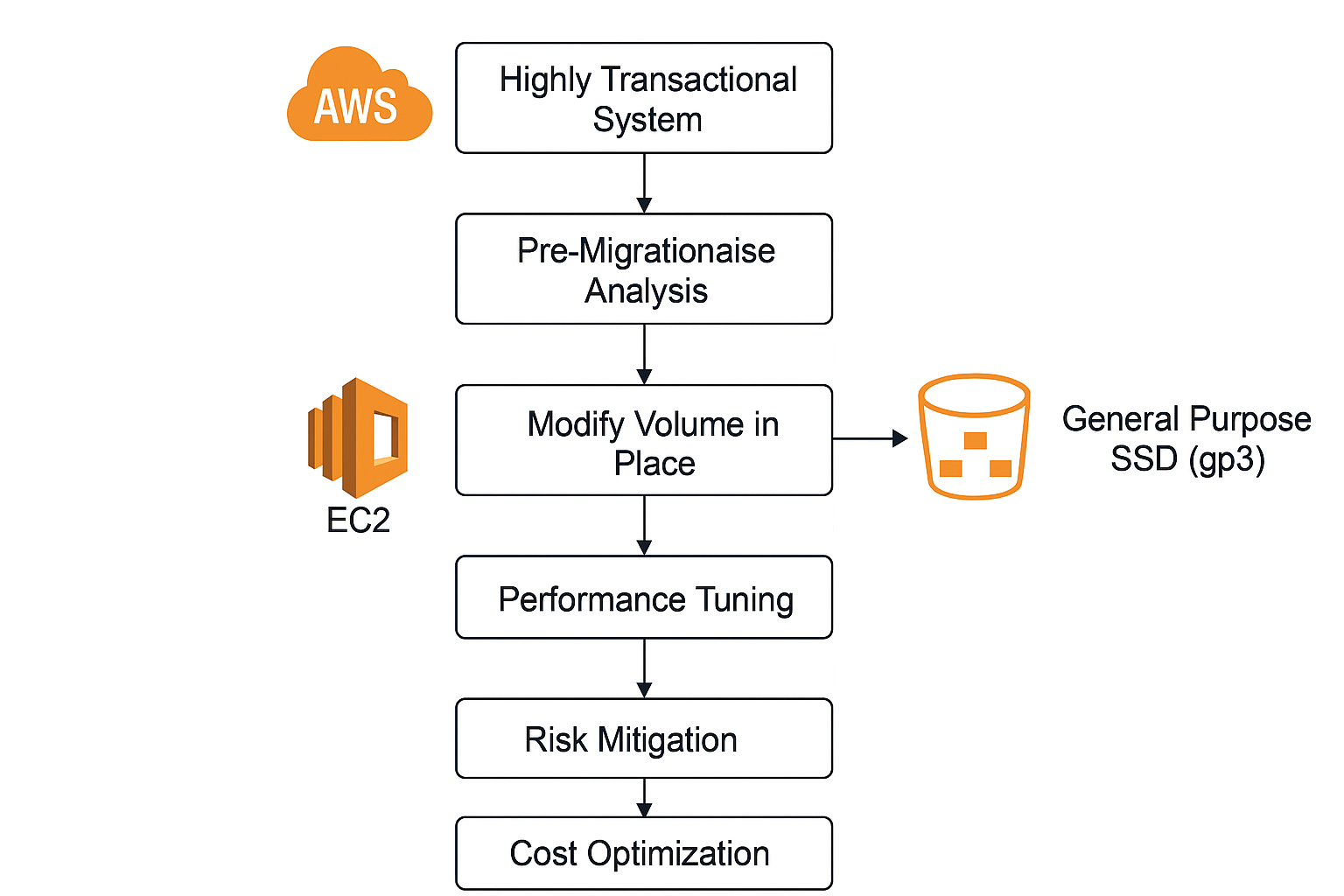

**Scenario 2: Your application uses several EC2 instances that exhibit high CPU and low memory utilization. How would you approach resizing the instances to balance performance and cost? Which AWS tools or strategies would you use to make data-driven decisions?**

**Ans: -** **Here’s how an AWS expert with 11 years of experience would approach this scenario:**

**✅ Problem**

* **EC2 instances show high CPU utilization and low memory utilization.**
* **Goal: Balance performance and cost by resizing instances.**

**✅ Step 1: Analyze Current Utilization**

* **Use Amazon CloudWatch:** 
  + **Metrics: CPUUtilization, MemoryUtilization (via CloudWatch Agent), NetworkIn/Out, DiskReadOps.**
* **Identify:** 
  + **Average and peak CPU usage.**
  + **Memory usage trends.**
  + **Workload patterns (steady vs bursty).**

**✅ Step 2: Determine Instance Type**

* **Current instance likely compute-heavy workload.**
* **If CPU is high and memory is underutilized:** 
  + **Move to Compute Optimized (C family) instances (e.g., c6i, c7g).**
  + **Avoid Memory Optimized (R family) since memory is not a bottleneck.**
* **Consider smaller size within same family if CPU is not maxed out at peak.**

**✅ Step 3: Use AWS Tools for Data-Driven Decisions**

* **AWS Compute Optimizer:** 
  + **Provides recommendations based on historical utilization.**
  + **Suggests optimal instance type and size.**
* **AWS Cost Explorer:** 
  + **Analyze cost impact of resizing.**
* **AWS Trusted Advisor:** 
  + **Check for over-provisioned resources and cost optimization opportunities.**

**✅ Step 4: Strategy for Resizing**

* **Right-size instances:** 
  + **Example: If using m5.4xlarge (balanced), move to c6i.2xlarge (compute optimized).**
* **Test in Staging:** 
  + **Validate performance before applying to production.**
* **Use Auto Scaling:** 
  + **For variable workloads, configure CPU-based scaling policies.**
* **Leverage Savings Plans or Reserved Instances:** 
  + **After resizing, commit for cost savings.**

**✅ Step 5: Risk Mitigation**

* **Perform resizing during maintenance window.**
* **Use Elastic Load Balancer and Auto Scaling Groups for zero-downtime migration.**
* **Snapshot or AMI backup before changes.**

**✅ Summary**

* **Tools: CloudWatch, Compute Optimizer, Cost Explorer, Trusted Advisor.**
* **Approach: Profile → Analyze → Right-size → Validate → Optimize cost.**
* **Outcome: Lower cost, better CPU efficiency, minimal memory waste.**

**Scenario 3: You’re tasked with reducing costs in an auto-scaling group where the workload has unpredictable spikes. How would you redesign the auto-scaling policies to optimize both cost and performance?**

**Here’s a strong, senior-level answer for Scenario 3:**

**✅ Scenario**

**Workload has unpredictable spikes in an Auto Scaling Group (ASG). Goal: Reduce cost while maintaining performance.**

**✅ Approach to Redesign Auto Scaling Policies**

**1. Analyze Current Behavior**

* **Use Amazon CloudWatch metrics:** 
  + **CPUUtilization, RequestCount, Latency.**
* **Identify patterns: Are spikes short-lived or sustained? Are they predictable by time or event?**

**2. Implement Dynamic Scaling**

* **Replace simple step scaling with Target Tracking Scaling:** 
  + **Example: Maintain CPU at 50–60% utilization.**
  + **Automatically adjusts capacity up/down based on real-time metrics.**
* **Use Predictive Scaling:** 
  + **Leverages ML to forecast future demand and pre-scale before spikes.**

**3. Optimize Instance Types**

* **Use AWS Compute Optimizer to right-size instances.**
* **Consider Burstable Instances (T family) for workloads with intermittent spikes.**
* **For sustained spikes, use C family (compute optimized) with Auto Scaling.**

**4. Cost Optimization Strategies**

* **Mixed Instance Policies:** 
  + **Combine On-Demand, Spot, and Reserved Instances in ASG.**
  + **Spot for cost savings during spikes, On-Demand for baseline stability.**
* **Instance Weighting:** 
  + **Allow different instance sizes in the same ASG for flexibility.**
* **Use EC2 Auto Scaling with EC2 Fleet:** 
  + **Diversify across instance types and AZs for resilience and cost efficiency.**

**5. Additional Enhancements**

* **Cooldown Periods:** 
  + **Prevent rapid scale-in/out that increases cost.**
* **Lifecycle Hooks:** 
  + **Ensure graceful scale-in (e.g., drain connections before terminating).**
* **Load Balancer Integration:** 
  + **Attach ASG to ALB for even traffic distribution during scaling.**

**✅ AWS Tools to Use**

* **CloudWatch: Metrics & alarms for scaling triggers.**
* **AWS Auto Scaling: Target tracking, predictive scaling.**
* **Compute Optimizer: Instance right-sizing.**
* **Cost Explorer: Analyze cost impact.**
* **Trusted Advisor: Cost optimization checks.**

**✅ Expected Outcome**

* **Performance: Spikes handled proactively with predictive scaling.**
* **Cost: Reduced by Spot integration, right-sizing, and dynamic scaling.**
* **Resilience: Mixed instance types and AZ diversification.**

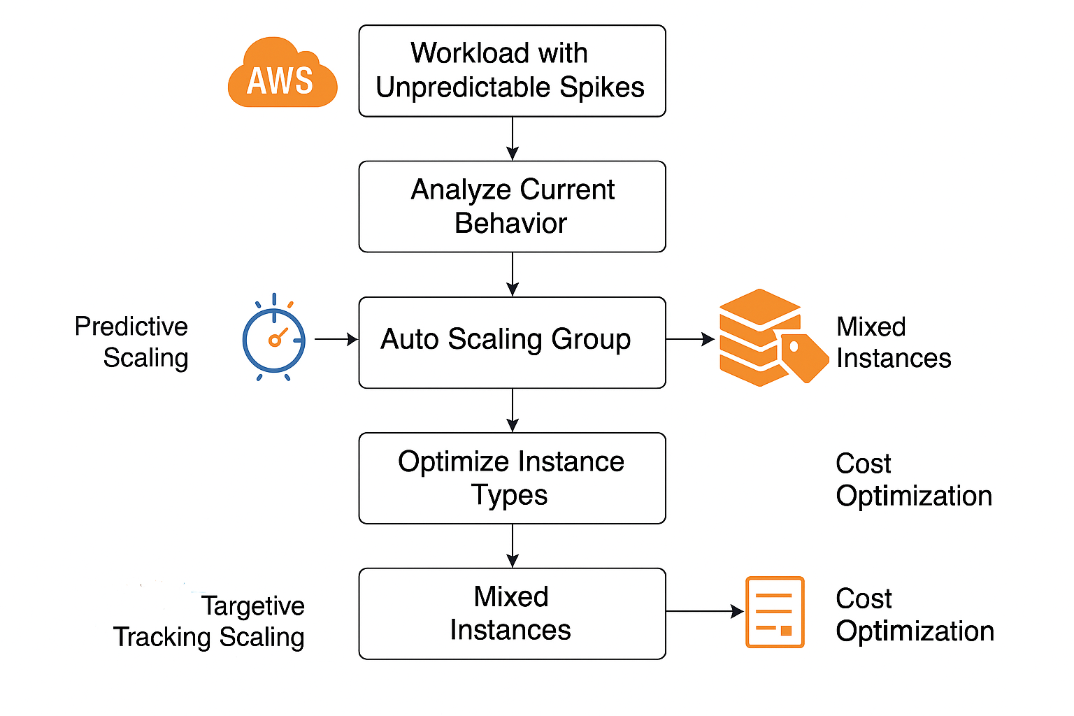

**Here’s the visual flowchart showing the redesigned Auto Scaling strategy:**

**✅ Flow Breakdown**

1. **Workload with Unpredictable Spikes**
   * **Start with analyzing current behavior using CloudWatch metrics.**
2. **Auto Scaling Group**
   * **Apply Predictive Scaling (forecast demand using ML).**
   * **Apply Target Tracking Scaling (maintain CPU or request count at target).**
3. **Optimize Instance Types**
   * **Use Compute Optimizer for right-sizing.**
   * **Choose Burstable (T family) or Compute Optimized (C family) as needed.**
4. **Mixed Instances Policy**
   * **Combine On-Demand, Spot, and Reserved Instances for cost efficiency.**
   * **Enable Instance Weighting for flexibility.**
5. **Cost Optimization**
   * **Use Savings Plans, Cost Explorer, and Trusted Advisor.**

**Scenario 4: During performance testing, you notice a bottleneck caused by a third-party API call. What strategies would you use to cache the API response and reduce costs? Explain how you would balance caching costs with API request savings.**

**Ans:**

Great question! When performance testing reveals a bottleneck due to a third-party API, caching can significantly reduce latency and costs. Here’s how I would approach it:

1. Strategies for Caching API Responses

* In-Memory Cache (e.g., Redis, Memcached):
  + Store frequently accessed API responses in memory for ultra-fast retrieval.
  + Ideal for short-lived data (seconds to minutes).
* Persistent Cache (e.g., Database or Disk):
  + For data that doesn’t change often, store responses in a database or file system.
  + Useful for long-lived data (hours to days).
* Client-Side Caching:
  + Use HTTP caching headers (ETag, Cache-Control, Expires) so clients reuse responses without hitting your server.
* Reverse Proxy Cache (e.g., Varnish, CDN):
  + Cache responses at the edge to reduce API calls and improve global performance.
* Hybrid Approach:
  + Combine in-memory for hot data and persistent for cold data.

2. Balancing Caching Costs vs API Request Savings

* Cost Factors:
  + Caching Costs: Memory (RAM), storage, infrastructure (Redis clusters, CDN).
  + API Costs: Per-request charges, latency impact, rate limits.
* Decision Framework:
  + Calculate API cost per request vs cache cost per GB/hour.
  + Estimate hit ratio (percentage of requests served from cache).
  + Use formula: $\text{Savings}=(\text{API Cost}×\text{Requests Avoided})-\text{Cache Cost}$
* TTL (Time-to-Live) Optimization:
  + Short TTL for dynamic data to avoid stale responses.
  + Long TTL for static or rarely changing data.
* Eviction Policy:
  + Use LRU (Least Recently Used) or LFU (Least Frequently Used) to keep cache efficient.

3. Practical Example

* Suppose:
  + API cost = $0.01 per call
  + 1M requests/month → $10,000
  + Redis cost = $500/month
  + If caching reduces 80% of calls:
    - Savings = (0.01 × 800,000) - 500 = $7,500 net savings.
* This shows caching is highly cost-effective when hit ratio is high.

**Scenario 5**: A team requests a recommendation to reduce the cost of large-scale video transcoding. Would you suggest a serverless solution (like AWS Lambda) or spot instances? Justify your answer in terms of both cost and performance.

**Caching**

**Scenario 6**: You’re tasked with optimizing read-heavy database workloads with a caching layer. How would you decide between Redis and Memcached, considering both cost and performance?

**Scenario 7**: A web application uses an in-memory cache (Redis) extensively. How would you tune the eviction policies and TTL settings to ensure that the cache provides optimal cost-to-performance benefits during traffic spikes?

**Scenario 8**: An API gateway is experiencing frequent cache misses, leading to increased response times. What strategies would you implement to minimize cache misses while keeping the cost under control?

**Scenario 9**: You’re managing a distributed cache across multiple regions to serve a global user base. What are some cost-effective ways to minimize data replication lag while maximizing cache performance?

**Scenario 10**: A business-critical application relies heavily on database queries. How would you architect a cost-effective read-through or write-through cache solution that doesn’t compromise the performance or availability of the database?

**Database Optimization**

**Scenario 11**: Your organization is migrating from an on-premises SQL database to a cloud-based managed database (RDS). What strategies would you implement to optimize performance while keeping costs under control?

**Scenario 12**: A mission-critical database has unpredictable traffic patterns and fluctuating workloads. How would you design a scaling strategy for Aurora (or another cloud-native database) to handle such traffic efficiently while minimizing costs?

**Scenario 13**: You’re tasked with reducing the storage costs of a database containing 10 years of historical data, which is queried rarely. Describe your approach to partitioning or archiving this data while keeping query performance acceptable.

**Scenario 14**: Your relational database is suffering from slow queries due to poorly designed indexes. How would you systematically identify and optimize the most expensive queries without driving up operational costs?

**Scenario 15**: A NoSQL database workload has heavy write activity, and you’re experiencing bottlenecks. What would be your approach to optimize both the performance and the cost of the NoSQL database?

**Networking**

**Scenario 16**: A global application suffers from high latency between users in different regions. How would you use a combination of CDN and Anycast routing to reduce latency while controlling the costs associated with these services?

**Scenario 17**: Your application uses multiple VPCs in different AWS regions. How would you optimize the cross-region data transfer costs while ensuring low latency and high availability?

**Scenario 18**: A large-scale microservices architecture is seeing significant costs from inter-service communication due to network traffic. How would you approach minimizing these costs while maintaining performance and reliability?

**Scenario 19**: You’re tasked with optimizing the costs for a system that uses large amounts of network bandwidth for data replication between regions. What techniques or AWS services would you recommend to minimize data transfer costs?

**Scenario 20**: Your company’s hybrid cloud setup uses both AWS and on-premises infrastructure. Describe a strategy to minimize the cost of data transfer between the on-prem network and the cloud.

**Cloud Resource Utilization**

**Scenario 21**: You’re responsible for identifying underutilized cloud resources in a large enterprise. What steps would you take to efficiently identify and address these resources without negatively affecting performance?

**Scenario 22**: Some resources in your AWS environment appear to be over-provisioned. Describe how you would use AWS Cost Explorer, Trusted Advisor, or similar tools to optimize these resources without compromising performance.

**Scenario 23**: Write a script that helps identify under-utilized EC2 instances across multiple regions. How would you ensure that the script takes into account utilization patterns to avoid prematurely decommissioning critical resources?

**Scenario 24**: A team reports that their reserved instances aren’t being fully utilized. How would you design a strategy to shift workloads to maximize the use of reserved instances without affecting performance?

Get Sam Atmaramani’s stories in your inbox

Join Medium for free to get updates from this writer.

Subscribe

**Scenario 25**: For a Kubernetes cluster running on AWS, how would you balance the use of spot instances and on-demand instances to minimize costs while maintaining high availability?

**Cost Control in Cloud Environments**

**Scenario 26**: Your company’s cloud bill has been rising, and management has asked for a 20% reduction. How would you audit the infrastructure to achieve this reduction without affecting performance?

**Scenario 27**: You’re tasked with creating a highly available system across multiple AWS regions. What strategies would you use to minimize cross-region replication and data transfer costs while maintaining reliability?

**Scenario 28**: A data processing pipeline in your environment is over-provisioned for the task it handles, but it needs to handle occasional large spikes. How would you optimize its resource usage and scale dynamically to avoid unnecessary costs?

**Scenario 29**: You need to reduce the costs of running a fleet of EC2 instances but still handle unpredictable workloads. What combination of reserved instances, spot instances, and savings plans would you recommend, and how would you manage the risks?

**Scenario 30**: An organization uses a cloud-native service (e.g., AWS Lambda) for a compute-intensive task that results in unexpectedly high costs. How would you profile the workload and suggest a more cost-efficient architecture?

**Monitoring and Cost Management]**

**Scenario 31**: You’re responsible for implementing cost and performance monitoring for a multi-cloud environment. What tools and strategies would you use to ensure you’re capturing relevant metrics to optimize resource usage and costs?

**Scenario 32**: A company is running high I/O workloads on a storage-optimized instance but is unsure if it’s cost-effective. How would you identify whether the instance type is over-provisioned and recommend a more appropriate instance type or storage option?

**Scenario 33**: You have a set of on-demand instances running 24/7 in a development environment. How would you design a strategy to reduce costs by managing instance lifecycles more effectively?

**Scenario 34**: Describe how you would implement automated scaling policies that account for both cost and performance for a stateless, cloud-native application hosted on AWS.

**Scenario 35**: How would you optimize a complex application that runs a mix of on-demand, reserved, and spot instances across multiple availability zones to reduce costs without compromising on performance?

**Automation and Scripting**

**Scenario 36**: You need to write an automation script to deallocate idle resources in an AWS environment. How would you handle edge cases where certain resources should not be shut down even if underutilized?

**Scenario 37**: Write a script that periodically checks for and deallocates orphaned resources (e.g., EBS volumes, Elastic IPs, etc.). How would you ensure that this script doesn’t accidentally delete resources in use?

**Scenario 38**: Your company wants to optimize the deployment of containers on AWS Fargate to reduce costs. How would you approach tuning task and service configurations to achieve this?

**Scenario 39**: You need to create a CloudFormation template that provisions a cost-optimized multi-tier web application on AWS. What key design principles would you apply to ensure performance isn’t compromised?

**Scenario 40**: You’re tasked with writing an automated tool to adjust resource allocations based on utilization thresholds. How would you balance performance, availability, and cost efficiency in your design?

**Advanced Optimization Techniques**

**Scenario 41**: A machine learning team is using GPU instances to train models, but the team reports under-utilization. How would you approach optimizing instance usage and minimizing costs, considering performance needs?

**Scenario 42**: You’re responsible for a legacy monolithic application that’s being migrated to the cloud. What steps would you take to ensure a smooth migration while minimizing

**Scenario 43:** Your company runs periodic batch processing workloads that require high throughput but are currently over-provisioned in terms of computer resources. How would you redesign the batch processing architecture to use spot instances or serverless solutions to reduce costs without sacrificing throughput?

**Scenario 44:** You’re optimizing a distributed system running large-scale simulations. The team reports high costs due to unnecessary resource contention and excessive inter-node communication. How would you optimize the system’s architecture to minimize inter-node traffic and reduce operational costs?

**Scenario 45:** A critical AI inference workload uses FPGA instances, but the cost is becoming prohibitive. How would you evaluate whether to switch to other specialized instance types (like GPU or CPU instances) while ensuring the performance required for real-time inferences remains intact?

**Disaster Recovery & High Availability**

**Scenario 46:** Your company has a mission-critical application that must be highly available across multiple regions. You are tasked with designing a disaster recovery (DR) plan. How would you balance the cost of a hot DR solution (active-active) with performance and availability needs?

**Scenario 47:** You’re tasked with setting up a scalable, highly available architecture for an e-commerce platform that must handle unpredictable traffic surges. Describe how you would configure load balancing, auto-scaling, and failover mechanisms while keeping infrastructure costs at a minimum.

**Scenario 48:** In a hybrid cloud setup, your company wants to ensure seamless failover between on-premises and cloud environments in case of disaster, but without maintaining full replicas in both environments due to cost concerns. How would you design a cost-effective disaster recovery strategy in this scenario?

**Scenario 49:** You’re responsible for an application that requires both high availability and low latency, but your budget is constrained. How would you design a multi-region, fault-tolerant architecture using AWS services like Route 53, RDS Multi-AZ, and S3, ensuring minimal failover downtime and cost?

**Scenario 50:** Your organization’s cloud bill is skyrocketing due to redundant high-availability setups across multiple regions. How would you consolidate the infrastructure to reduce redundancy and costs while still maintaining a strong disaster recovery posture? Feel free to follow me below social handles

*********************************************************************************

**AWS/Cloud Terms and meaning**

**********************************************************************************

An **isolated execution environment** refers to a computing setup where code runs in a controlled, separate space, preventing interference with other processes or systems. This concept is widely used for security, reliability, and reproducibility. Here’s a quick breakdown:

**Key Characteristics**

* **Isolation**: The environment is separated from the host system and other environments.
* **Controlled Resources**: CPU, memory, and network access can be limited.
* **Security**: Prevents malicious code from affecting the host or other applications.
* **Reproducibility**: Ensures consistent behavior across different machines.

**Common Implementations**

* **Virtual Machines (VMs)**: Full OS-level isolation using hypervisors.
* **Containers (e.g., Docker)**: Lightweight isolation using OS-level features.
* **Sandboxes**: Often used for testing untrusted code.
* **Serverless Functions**: Each function runs in its own isolated context.

**Use Cases**

* Running untrusted code safely.
* Testing software in a clean environment.
* Cloud deployments for scalability and security.
* CI/CD pipelines for reproducible builds.

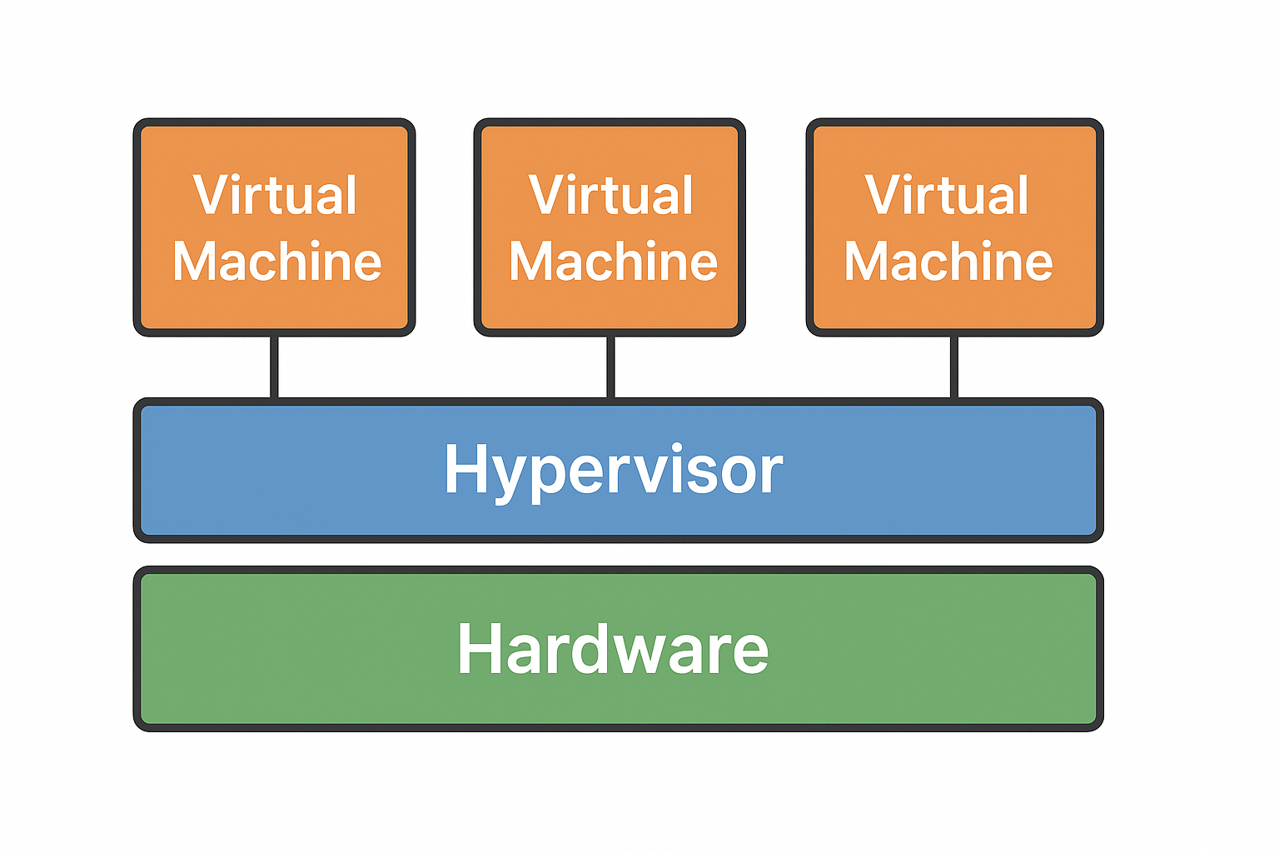

A **hypervisor** is a software layer (or sometimes firmware) that allows multiple **virtual machines (VMs)** to run on a single physical machine by managing and allocating hardware resources.

**Key Points About Hypervisors**

* **Purpose**: It abstracts the physical hardware and provides each VM with its own virtualized hardware environment.
* **Role**: Acts as a mediator between the physical hardware and the virtual machines.

**Types of Hypervisors**

1. **Type 1 (Bare-metal)**
   * Runs directly on the physical hardware.
   * Examples: VMware ESXi, Microsoft Hyper-V, Xen.
   * **Pros**: High performance, better security.
   * **Use Case**: Data centers, enterprise virtualization.
2. **Type 2 (Hosted)**
   * Runs on top of a host operating system.
   * Examples: VirtualBox, VMware Workstation.
   * **Pros**: Easier to set up, good for development/testing.
   * **Use Case**: Personal computers, software testing.

**Why is it important?**

* Enables **server consolidation** (multiple VMs on one machine).
* Improves **resource utilization**.
* Provides **isolation** for security and stability.

**✅ Compare VMs vs Containers vs Sandboxes in detail?**

**Copilot said:**

**Copilot**

**Here’s a detailed comparison of Virtual Machines (VMs), Containers, and Sandboxes:**

**1. Virtual Machines (VMs)**

* **Definition: A VM emulates an entire operating system on top of a hypervisor.**
* **Isolation Level: Full OS-level isolation. Each VM has its own kernel.**
* **Resource Overhead: High (each VM runs a full OS).**
* **Performance: Slower startup and heavier resource usage compared to containers.**
* **Security: Strong isolation; harder for malware to escape.**
* **Use Cases:**
  + **Running multiple OS types on one machine.**
  + **Legacy application support.**
  + **Strong security boundaries in cloud environments.**

**2. Containers**

* **Definition: Lightweight virtualization using OS-level features (namespaces, cgroups).**
* **Isolation Level: Process-level isolation within the same OS kernel.**
* **Resource Overhead: Low (shares host OS kernel).**
* **Performance: Fast startup, efficient resource usage.**
* **Security: Good, but weaker than VMs (kernel shared).**
* **Use Cases:**
  + **Microservices architecture.**
  + **CI/CD pipelines.**
  + **Cloud-native apps.**

**3. Sandboxes**

* **Definition: A restricted environment for running code, often in memory or with limited system access.**
* **Isolation Level: Varies; usually application-level isolation.**
* **Resource Overhead: Minimal.**
* **Performance: Very fast; often used for short-lived tasks.**
* **Security: Designed to prevent code from accessing sensitive resources.**
* **Use Cases:**
  + **Running untrusted scripts (e.g., browser JavaScript).**
  + **Malware analysis.**
  + **Secure plugin execution.**
* **Comparison Table**

| **Feature** | **VMs** | **Containers** | **Sandboxes** |
| --- | --- | --- | --- |
| Isolation Level | Full OS | Process-level | Application-level |
| Startup Time | Slow | Fast | Instant |
| Resource Usage | High | Low | Very Low |
| Security | Strong | Moderate | High (limited scope) |
| Portability | High | High | Low |
| Typical Use Case | Multi-OS environments | Cloud-native apps | Code testing, security |

**********************************************************************************

A **fleet of EC2 instances** refers to a group of Amazon EC2 (Elastic Compute Cloud) virtual machines running together, typically for scalability, high availability, or distributed workloads.

**Key Characteristics of an EC2 Fleet**

* **Multiple Instances**: Can include different instance types and sizes.
* **Elasticity**: Automatically scales up or down based on demand.
* **Diverse Purchase Options**:
  + **On-Demand**: Pay per hour/second.
  + **Reserved**: Long-term commitment for cost savings.
  + **Spot**: Use spare capacity at lower cost.
* **Managed via EC2 Fleet or Auto Scaling Groups**:
  + EC2 Fleet lets you launch a mix of instance types across Availability Zones.
  + Auto Scaling ensures the fleet adjusts to traffic or workload changes.

**Why Use an EC2 Fleet?**

* **Cost Optimization**: Combine On-Demand, Reserved, and Spot instances.
* **Performance**: Distribute workloads across multiple instance types.
* **Resilience**: Spread across multiple AZs for fault tolerance.

**Show an architecture diagram of an EC2 Fleet with Auto Scaling and Load Balancer?**

Here’s the architecture diagram for an **EC2 Fleet with Auto Scaling and Load Balancer**:

* **Top Layer**: **Load Balancer** distributes incoming traffic across instances.
* **Middle Layer**: **Auto Scaling Group** dynamically adds/removes EC2 instances based on demand.
* **Bottom Layer**: **EC2 Instance Fleet** (multiple instances running your application).

**Explain how to configure an EC2 Fleet in AWS step-by-step**?

Here’s a **step-by-step guide to configure an EC2 Fleet in AWS**:

**✅ Step 1: Sign in to AWS Management Console**

* Go to **EC2 Dashboard**.
* Ensure you have the necessary IAM permissions for EC2 Fleet and Auto Scaling.

**✅ Step 2: Create an EC2 Launch Template**

* Navigate to **Launch Templates** → **Create Launch Template**.
* Specify:
  + **AMI (Amazon Machine Image)** for your OS.
  + **Instance Type** (e.g., t3.medium).
  + **Key Pair** for SSH access.
  + **Security Group** for firewall rules.
* Save the template.

**✅ Step 3: Configure EC2 Fleet**

* Go to **EC2 → Fleets → Create Fleet**.
* Select your **Launch Template**.
* Define:
  + **Target Capacity** (number of instances).
  + **Instance Types Mix** (optional for cost optimization).
  + **Purchase Options**:
    - On-Demand
    - Spot Instances
    - Reserved Instances
* Choose **Allocation Strategy**:
  + **Lowest Price** (cost-efficient).
  + **Diversified** (spread across types for resilience).

**✅ Step 4: Add Auto Scaling**

* Go to **Auto Scaling Groups → Create Auto Scaling Group**.
* Select the **Launch Template**.
* Configure:
  + **Desired Capacity**, **Min**, and **Max Instances**.
  + **Scaling Policies** (CPU utilization, custom metrics).
* Attach to **Load Balancer** (Application or Network LB).

**✅ Step 5: Attach Load Balancer**

* Create or select an **Elastic Load Balancer**.
* Register the Auto Scaling Group with the Load Balancer.
* Configure **Health Checks** for instance replacement.

**✅ Step 6: Test and Monitor**

* Use **CloudWatch** for monitoring metrics.
* Verify scaling works by simulating load.
* Check **Fleet Status** in EC2 Dashboard.

************************************************************************************************

**✅ 1. AWS Provisioning Methods**

Provisioning means setting up resources (compute, storage, networking) in AWS. There are three main approaches:

**a) Manual Provisioning**

* Done via **AWS Management Console**.
* Click-based, good for quick tests or small setups.
* **Cons**: Error-prone, hard to scale, no version control.

**b) Automated Provisioning**

* Uses **AWS CLI** or **SDKs**.
* Example: aws ec2 run-instances to launch EC2.
* **Pros**: Scriptable, repeatable.
* **Cons**: Still lacks full infrastructure-as-code benefits.

**c) Infrastructure as Code (IaC)**

* Define resources in code (declarative or imperative).
* Tools:
  + **Terraform** (multi-cloud, open-source).
  + **AWS CloudFormation** (AWS-native).
  + **AWS CDK** (uses real programming languages).
* **Pros**: Version control, automation, consistency, easy rollback.

**✅ 2. Steps to Provision Resources in AWS**

Here’s an example for **EC2, S3, and RDS**:

**EC2 Instance**

* **Console**: EC2 → Launch Instance → Choose AMI → Instance Type → Configure → Launch.
* **CLI**:

Shell

aws ec2 run-instances --image-id ami-xxxx --instance-type t3.micro --key-name my-key --security-group-ids sg-xxxx --subnet-id subnet-xxxx

Show more lines

**S3 Bucket**

* **Console**: S3 → Create Bucket → Name + Region → Configure → Create.
* **CLI**:

Shell

aws s3 mb s3://my-bucket-name

Show more lines

**RDS Database**

* **Console**: RDS → Create Database → Choose Engine → Configure → Launch.
* **CLI**:

Shell

aws rds create-db-instance --db-instance-identifier mydb --db-instance-class db.t3.micro --engine mysql --allocated-storage 20

Show more lines

**✅ 3. Best Practices for AWS Provisioning**

* **Security**:
  + Use **IAM roles** instead of hardcoding credentials.
  + Apply **least privilege** principle.
  + Enable **encryption** (EBS, S3, RDS).
* **Cost Optimization**:
  + Use **Auto Scaling** for EC2 fleets.
  + Prefer **Spot Instances** for non-critical workloads.
  + Enable **S3 lifecycle policies** for storage cost control.
* **Reliability**:
  + Deploy across **multiple Availability Zones**.
  + Use **Load Balancers** for high availability.
* **Automation**:
  + Use **IaC tools** for repeatability and version control.
  + Integrate with **CI/CD pipelines**.

**✅ 4. Terraform vs CloudFormation vs CDK**

| **Feature** | **Terraform** | **CloudFormation** | **AWS CDK** |
| --- | --- | --- | --- |
| **Scope** | Multi-cloud | AWS-only | AWS-only |
| **Language** | HCL (HashiCorp Config) | JSON/YAML | Real languages (Python, TS) |
| **State Mgmt** | External state file | Managed by AWS | Managed by AWS |
| **Modularity** | Strong (modules) | Nested stacks | Constructs & classes |
| **Learning Curve** | Moderate | Easy for AWS users | Easy for developers |
| **Community** | Large, active | AWS ecosystem | Growing fast |

**Recommendation**:

* **Terraform** → Best for multi-cloud or hybrid environments.
* **CloudFormation** → Best for AWS-only, simple setups.
* **CDK** → Best for developers who prefer coding in Python/TypeScript.

******************************************************************************************************************************

**AWS Transit Gateway (TGW)** is a **networking service** that acts as a **central hub** to connect multiple **Amazon VPCs**, **on-premises networks**, and even **VPNs or Direct Connect** links. It simplifies complex network architectures by replacing multiple peering connections with a single scalable solution.

**✅ What is AWS Transit Gateway?**

* A **regional network transit hub**.
* Allows thousands of VPCs and on-premises networks to communicate through a single gateway.
* Uses **high-performance routing** internally managed by AWS.

**Key Features**

* **Centralized Connectivity**: One TGW can connect multiple VPCs and on-premises networks.
* **Scalability**: Supports thousands of VPC attachments.
* **Simplified Management**: Reduces complexity compared to VPC peering.
* **High Bandwidth**: Up to **50 Gbps per VPC attachment**.
* **Integration**: Works with **VPN**, **Direct Connect**, and **AWS Network Firewall**.

**Use Cases**

* **Multi-VPC Architecture**: Large organizations with multiple accounts and VPCs.
* **Hybrid Cloud**: Connect on-premises data centers to AWS.
* **Centralized Security**: Apply firewall policies at TGW level.
* **Global Connectivity**: Combine TGW with **Transit Gateway Inter-Region Peering**.

**How TGW Works**

* You create a **Transit Gateway** in a region.
* Attach VPCs, VPNs, or Direct Connect gateways to TGW.
* TGW routes traffic between attachments using **route tables**.
* You can segment traffic using **multiple route tables** for isolation.

**Benefits Over VPC Peering**

| **Feature** | **VPC Peering** | **Transit Gateway** |
| --- | --- | --- |
| **Scalability** | Limited (mesh) | Thousands of VPCs |
| **Management** | Complex | Centralized |
| **Cross-Region** | Manual setup | Inter-Region Peering |

**Draw an architecture diagram of AWS Transit Gateway connecting multiple VPCs and on-premises networks?**

**Here’s the AWS Transit Gateway architecture diagram:**

* **Center: Transit Gateway acts as the hub.**
* **Connected Components:** 
  + **Multiple VPCs (orange boxes) attached to TGW.**
  + **On-Premises Network (green box) connected via VPN or Direct Connect.**
* **Purpose: TGW routes traffic between all these networks through a single point, simplifying connectivity.**